

LITERACY

POLICY

2026-2027

This document has been approved for operation for - Islamiyah Girls High School

Last Reviewed – June 2026

Next review – June 2027

Review Period – 1 Year

Owner – Islamiyah Girls High School

Approved By – Governing Body

CONTENTS
- Statement of Aims

- Prioritize ‘disciplinary literacy’ across the curriculum

- Provide targeted vocabulary instruction in every subject

- Develop students’ ability to read complex academic texts

- Break down complex writing tasks

- Combine writing instruction with reading in every subject

- Provide opportunities for structured talk

- Provide high quality literacy interventions for struggling students

Statement of Aims
“Read in the name of thy Lord who created; [He] created the human being from blood clot. Read in the name of thy Lord who taught by the pen: [He] taught the human being what he did not know.”
QURAN (96:1-5).
At Islamiyah High School we believe it is imperative to cultivate the development of our students reading skills and comprehension whilst nurturing a love of books and reading to create life-long readers. We recognise that these elements are not mutually exclusive but rather intertwined, and even interdependent to becoming life-long readers.
School leaders have developed a comprehensive whole-school literacy programme by reflecting on the very first verse revealed in holy scripture, “Read”. The most powerful and timeless tool to ensure academic, social, cultural, moral, and spiritual success. Therefore, we have developed a holistic literacy programme emulating the revelation which has both spiritual and academic significance.
Our literacy policy aims to develop a positive and rich reading culture, at IGHS we-
- We understand the importance of placing reading and books at the centre of the curriculum
- We believe every student with the correct teaching and support can read well
- We recognise the ability to read is a key life skill for all students
- We acknowledge not all students have the opportunity to read or develop a love of reading at home. Hence, school plays an essential role to not just teach but also encourage students to learn how to read, just like any other subject.
- We understand it takes time for students to become independent and voluntary readers
- We understand the importance of implementing effective strategies to promote reading for pleasure.
- We understand to encourage reading we need to establish and create a comfortable reading environment, including reading spaces.
- We believe every teacher should be an advocate for reading.
- We recognise staff training is imperative to support reading for skills and for pleasure, to create consistency as well as reiterate the value of reading across curriculums.
- We acknowledge we must build the bridge of reading between home and school by communicating with and involving parents to extend reading into the students home.
- We want all students to genuinely enjoy and love reading with passion.

Why literacy matters
Literacy is fundamental for success in school and later life. Students who cannot read, write, and communicate effectively are highly unlikely to access the challenging academic curriculum in secondary school and are more likely to have poor educational outcomes across all subjects. The academic challenges faced by students moving from primary to secondary education are often underestimated. For example, students in Year 7 must adjust to being taught by a range of teachers— often undertrained in the literacy demands of their subject —using a range of new types of texts, which are often dense and more technical than those encountered in primary school. Such challenges can create a ‘literacy gap’, meaning that many students making the transition from primary struggle to access the secondary school curriculum.

We are dedicated to cultivating a rich reading culture for various reasons, including-
  - Achievement
Research shows that children who enjoy reading achieve more highly right across the curriculum. Developing a love of reading is one of the most effective ways a school can raise attainment. Success in reading can improve national test results in all areas but, more importantly, it also sets children up as readers for life, with all the accompanying benefits that follow.
  - Entitlement
Every child deserves the chance to become a reader. For many children, including those growing up in a household where reading is not valued, school will be the key place where they come into contact with books. Children who are not introduced to books are missing out on a lifetime of enjoyment. So, if families are unable or unwilling to introduce children to reading, it falls to schools to take responsibility. If schools fail to do this, the consequences for children are stark. We know that links can be demonstrated between, for instance, illiteracy and offending.
  - The National Curriculum
The new National Curriculum for English places reading for pleasure at the heart of the English curriculum. Alongside the expectation that every school teaches children to read well, therefore IGHS is committed to instilling and nurturing a love of reading in every child.
  - Expanding children’s experience
Reading is a passport to the world. The benefits of reading go beyond the opportunities offered by being well-read with a good command of English. Reading great literature opens children up to ideas, experiences, places, and times they might never otherwise experience in real life. Reading for pleasure gives opportunities to learn about a multitude of things that cannot be covered by a school curriculum.
This policy emphasises that literacy programmes must not simply be seen as a basket of general skills. Instead, it must be grounded in the specifics of each subject. Crucially, this policy makes the case that by attending to the literacy demands of their subjects, teachers increase their students’ chance of success in their subjects. Our teachers should ask not what they can do for literacy, but what literacy can do for them. This policy is grounded on seven practical evidence-based recommendations, relevant to all students, based on the key concept of disciplinary literacy. It aims to support our teachers in all subjects with strategies to help students read, write, and communicate effectively. Our policy will cover seven key strategies IGHS will be implementing to improve the overall aptitude and competency of literary skills across key stage 3 and 4. The key strategies are as follows-
- Disciplinary literacy across the curriculum
- Targeted vocabulary instruction in every subject
- Develop students ability to read complex academic texts
- Break down complex writing tasks
- Combine writing instruction with reading in every subject
- Provide opportunities for structured talk
- Provide high quality literacy interventions for struggling students
- Developing the reading environment
- Celebrating reading

DISCIPLINARY LITERACY
“Disciplinary literacy recognises that literacy skills are both general and subject specific”
Disciplinary literacy is an approach to improving literacy across the curriculum. It recognises that literacy skills are both general and subject specific, emphasising the value of supporting teachers of every subject to teach students how to read, write and communicate effectively. As students’ progress through an increasingly specialised secondary school curriculum, there is a growing need to ensure that students are trained to access the academic language and conventions of different subjects. Strategies grounded in disciplinary literacy aim to meet this need, building on the premise that each subject has its own unique language, ways of knowing, doing, and communicating.
By anchoring literacy clearly in subjects, disciplinary literacy aims to support students to develop relevant ‘disciplinary habits of mind’. These are subtle but important differences in reading in subject specific ways. For example, in Biology, a student may read an informational text about photosynthesis and assume that is it an authoritative account, suppressing thoughts about the author of the text. In contrast, in the English classroom, a student could read with an active awareness of the author and the context in which the text was authored. For maths teachers, explicitly teaching mathematical vocabulary and specific reading strategies for written problems could support students to read like mathematicians.
The strategies utilised by IGHS to implement disciplinary literacy include-
  - Reading books are part of the school uniform
To emphasise and encourage the use of reading books, students are required to bring a reading book to school every single day. This will be considered as uniform, hence if students are found without a book, they will receive the same sanctions as though they have attended school without their correct uniform. This is important for students to intrinsically develop the habit of students carrying books with them, which will increase their likelihood to reach for books in their free time and personal reading time.
  - Sustained silent reading (SSR)
SSR is implemented in the school timetable by utilising specific reading windows in the school timetables such as form time. Students will be instructed to conduct independent silent reading during their form times on reading mornings.

  - Drop everything and read
The ‘Drop and read’ method can be an effective and stimulating way to promote additional reading in the school timetable. Teachers will ensure they provide a drop and read session at least once a week in their subjects. This would contribute to 5-10 minutes of additional reading per subject, per week.

  - Spelling Bee
To support the development of literary skills, each student in KS3 will be provided with a spelling book, which will be a compulsory component and considered as part of their uniform, as is their reading book and homework diary. Subject teachers will utilise the spelling book on a weekly basis to test students ability to spell at least 10 to 15 subject related vocabulary. For example, the geography teaching staff may test students on keywords relating to urbanisation or geology. This will be implemented consistently across all subjects, to improve spelling and encourage students to develop sophisticated vocabulary.

  - Marking- Teacher and student feedback (See marking policy)
Book marking is an incredibly important method of communicating with students alongside verbal communication. All subject staff will be required to read and implement the marking policy effectively. Teachers will ensure students receive sufficiently detailed feedback on their work, teachers must be vigilant to highlight any mistakes and suggest improvements for the spelling, punctuation, and
grammar of students. Teachers will provide a minimum of two comments ‘What went well’ and ‘Even better if’. Teachers will then prompt and provide students with the opportunity to respond to the feedback in their books.
  - Teacher Training
School leaders will consistently monitor the implementation of the ‘whole school literacy programme’. The programme is considered to be an evolving document to ensure progress following consistent analysis and evaluation. However, it is important for leaders to relay changes and improvement in the literacy programme during inset/teacher training days. Leaders should provide teaching staff, with time to reflect on the following-
  - What is unique about your subject discipline in terms of reading, writing, speaking, and listening? What is common with other subject disciplines?
  - How do members of this subject discipline use language on a daily basis?
  - Are there any typical literacy misconceptions held by students, for example, how to write an effective science report?
  - Are there words and phrases used typically, or uniquely, in the subject discipline?"

How IGHS will prioritise disciplinary literacy?
  - Auditing existing literacy practices, attitudes, and resources in school—involving both teachers and students; this could include an evaluation of existing literacy policies and roles such as the literacy coordinator.
  - Creating subject specific literacy plans, rooted in the discipline, that address barriers to accessing the curriculum related to reading, writing and communication.
  - Supporting teachers to define effective reading, writing, and talk in their subjects; for example, history teachers might discuss what reading strategies are deployed by historians to appraise historical sources.
  - Evaluating the quality and complexity of existing reading materials in school, assessing the degree of academic challenge such texts pose to our secondary school students as they progress through school, relating this to baseline data of students’ reading ability.
  - Ensuring that the development of disciplinary literacy is coherently aligned with curriculum development, for example, in Art, that the development of drawing skill is paired with teaching students how to make high quality annotations utilising specialist vocabulary.

TARGETED VOCABULARY

Students develop their language skills throughout secondary school as they read both in class and independently, and from engaging in academic talk and listening. Nurturing the development of the academic language of secondary school is crucial, given the increasingly specialised language of subject disciplines. This can be supported by targeted vocabulary instruction. One of the significant challenges in secondary schools is that all students must develop secure knowledge of the specialised and technical vocabulary needed to access the curriculum. As students move from one subject classroom to another, they need to navigate and switch between subtly different forms of communication and vocabulary use.
Increasing the challenge still further, the subject specific academic vocabulary of the subject disciplines differs considerably from the language students habitually use to communicate outside of the school gates. The specialised vocabulary of mathematics, for example, includes words that have a specific meaning in maths, but have different meanings in other contexts. For example, ‘factors’ of a number in mathematics has a different meaning to the ‘factors’ that influenced World War One in History. It is easy to see how confusion for students can occur. Other examples in mathematics include words like ‘value’, ‘prime’, ‘area’, ‘mean’, ‘fraction’, and ‘improper’.
Organising vocabulary into meaningful patters within and across subjects
At IGHS, we intend to define and characterise what makes the vocabulary of secondary school uniquely complex. Ultimately, the words and phrases used in the subject disciplines are more specialist and rarer than in everyday talk and language, but the patterns within specialist vocabulary can be used to help students overcome this complexity. A significant proportion of the subject specific vocabulary used in secondary school has ancient Greek and Latin origins. In Science and Maths, the proportion can be as high as 90%. This offers a challenge for our students, but also an opportunity. Academic vocabulary helpfully includes common word roots (such as, ‘geo’ or ‘bio’),
prefixes (such as ‘un-’ and ‘re-’) and suffixes (such as, ‘-ing’ and ‘-ed’). Teachers can use approaches to vocabulary instruction based in etymology and morphology to help students understand and remember new words.
Etymology is the study of the origin of words. In Biology, for example, a teacher introducing students to the concept of “symbiosis” might emphasise the origin of the word to explain the concept in a memorable way. Symbiosis derives from the Greek for “companion” and “a living together”. This hook can help students remember the idea that symbiosis involves close physical association and is mutually beneficial.
Morphology is the study of the structure and parts of words. The mathematics teacher, for example, might explore the Latin prefixes in shapes and key terms and explicitly encourage students to spot the patterns between words: for example, between quarter and quadrilateral, triangle, and triple.
Patterns can also cross subjects, for example from octagon in Maths to octave in Music. Some words change their meaning over time, so in subjects like English Literature, awareness that the word ‘brave’ meant barbarous in the 15th century but that its meaning has evolved over time, is valuable for interpreting older literary texts.

Teachers can also deepen students’ understanding of vocabulary using graphic organisers, such as
concept maps and the Frayer Model.
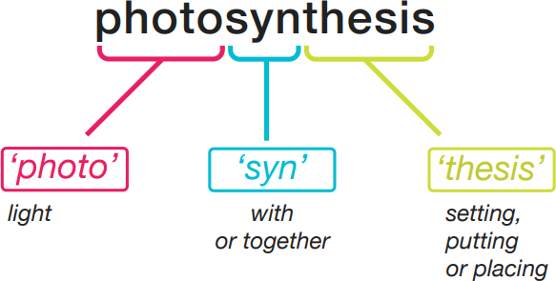

FIGURE 1- The morphology of photosynthesis

Isabel Beck and colleagues developed a model presenting tiers of vocabulary that helpfully delineates between vocabulary used in subject disciplines and across the curriculum (see Figure 3).17,18 A key insight from this model is the need to explicitly teach Tier 2 and Tier 3 vocabulary, which will be unfamiliar to many students.
Tiers of vocabulary
IGHS will be utilising the ‘Tiers of vocabulary’ model, developed by Beck et al, that helpfully delineates between vocabulary used in subject disciplines and across the curriculum (see Figure 2). A key insight from this model is the need to explicitly teach Tier 2 and Tier 3 vocabulary, which will be unfamiliar to many students.

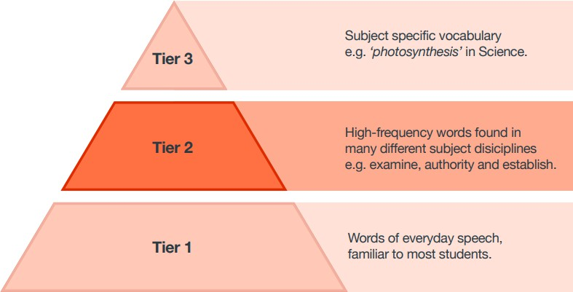

FIGURE 2- The tiers of vocabulary

Strategies implemented by IGHS to teach vocabulary explicitly in the classroom:
- Exploring common word roots- For example, science teacher when analyzing the etymology of ‘photo’ (‘light’) may ask students to explore other scientific vocabulary that includes the root ‘photo’ such as ‘photosynthesis’, ‘photobiotic’ and ‘photon’.
- Undertaking ‘word building’ activities, such as matching prefixes and root words for example,
‘anti-body’ or ‘anti-matter.’
- Encouraging independent word-learning strategies, such as how to break down words into parts and how to use dictionaries, to support students as they read more widely.
- Using graphic organisers and concept maps to break down complex academic terms in visual ways to aid understanding.
- Undertaking regular low-stakes assessment, such as quizzes, to provide multiple exposures to complex subject specific vocabulary, before applying this vocabulary in use, for example, in essay writing.
- Consistently signposting synonyms so that students recognise how some Tier 2 vocabulary items can enhance the accuracy and sophistication of their talk and writing in the subject domain.
- Combining vocabulary development with spelling instruction. For example, highlighting morphological patterns that determine complex spelling of subject specific vocabulary.
Practical implementation example-
Subject disciplines will identify academic vocabulary needed for each topic and scheme of work (15-20 words) and these are explicitly taught using, among other approaches, the Frayer model. These graphic organisers have a common format, including a student friendly definition, an image to support (based upon the principles of dual coding), characteristics of the word, morphology (linked also to word families), etymology (where relevant), and examples of its use in the correct context.
Subject leaders will adapt the common template so that it best suits the academic requirements of their subject. English lessons, for example, explore common connotations to develop ‘depth’ of word knowledge. Explicit teaching is supported by regular teacher modelling (written and verbal), school displays and opportunities for deliberate practice using words in their correct context, both through structured discussion and written work. Memorisation of vocabulary, its use and meaning, is supported through spaced retrieval practice at the start of lessons and through homework using methods such as low-stakes quizzes and multiple-choice questions.

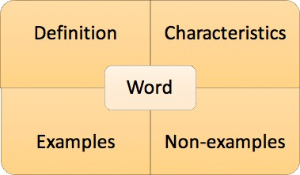
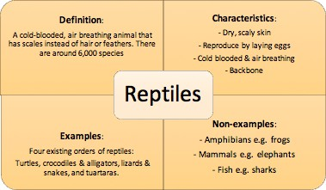

Figure 3- The Frayer model utilised as a starter activity to explore targeted vocabulary in lessons

There is a shared responsibility between senior leaders and subject leaders, including literacy coordinators, to support subject teachers to develop strategies to teach vocabulary effectively, and then align vocabulary instruction with curriculum development. To develop a coherent planning process that is undertaken in subject departments but led and supported across subjects. IGHS leaders, teaching and learning coordinators and literacy coordinators will-
  - Carefully select Tier 2 and Tier 3 vocabulary for explicit teaching as part of curriculum design.
  - Consider links between subjects in curriculum planning and teaching, for example recognising vocabulary that crosses subject disciplines as well as where misconceptions could arise from “false friends”.
  - Provide students with rich oral and written language environments (with opportunities for implicit learning) as well as directly teaching vocabulary (explicit learning) using approaches such as highlighting morphological patterns.
  - Provide multiple opportunities to hear, see and use new words; developing the number of words students know (breadth) and their understanding of relationships between words and the contexts in which words can be used (depth), for example, by exploring links between language used in different subject disciplines.
  - Use inset sessions to provide effective professional development opportunities, by asking teaching staff to work in departments to identify the essential Tier 2 and Tier 3 vocabulary that they will teach explicitly, and cumulatively, in their curriculum, consolidating students’ knowledge where appropriate.

DEVELOP PUPILS’ ABILITY TO READ AND ACCESS ACADEMIC TEXTS
All teachers will be supported to understand the fundamental ways in which students learn to read, and the most common barriers to their doing so. While most students begin secondary school with the general skills and knowledge needed to read accurately, fluently and with comprehension, some do not. In addition, teachers will be provided with training to ensure that they are able to teach reading in their subjects. A major part of the challenge of literacy in secondary school is related to demands of academic reading. Whilst some students may learn to navigate subject specific texts naturally, others are likely to struggle, particularly when working asked to work independently.
Professional development focused on teaching reading is likely to help teachers teach their subject more effectively, as well as providing teachers across subject disciplines with effective strategies to support students and a common language about reading instruction.
Three sources of information about general reading development for staff are:
  - The EEF’s Guidance Report Improving Literacy
  - Coventry University’s Literacy Development Evidence Review
  - Simple View of Reading by EEF The challenge of academic reading
Academic reading is challenging because it requires students to actively engage with complex, subject specific texts. For most students, reading comprehension is much more challenging than verbal comprehension, which typically contains less technical language and is accompanied by a range of additional cues that support understanding.
Take these sentences from a BBC Bitesize summary for GCSE Geography on ‘migration trends’:
“In 2004, Poland and seven other Eastern European countries joined the EU. This increased migration
into the UK.”
To comprehend these short sentences, students need to engage with what they are reading, drawing on what they already know and making new inferences to learn more. For example, to understand the link between the first and second sentences, students need to know that membership of the European Union entitles citizens of member states to freedom of movement. Additionally, students need to make inferences that go beyond the literal words in the sentence and draw upon their knowledge of their subject.
For example, they may draw upon their wider background knowledge to predict why migration is occurring across countries and link this to knowledge of human geography related to the economic and social factors that affect migration. Effective readers of informational texts continually draw upon a complex wealth of prior knowledge about the world and language, as well as their awareness of subject specific genres and vocabulary.
As students tackle a challenging text, they make sense of it by constructing a rich mental
representation (called a ‘situation model’) that goes far beyond a simple, literal interpretation. Drawing on their language skills, relevant background knowledge and ability to infer, readers develop their understanding, which is refined and adjusted as they learn more.

Developing students as strategic readers
Our reading strategies aim to support the active engagement with texts that improve comprehension. Given the complexity of academic reading, students need to be able to deploy an array of reading strategies, which can be modelled and practised in the classroom to develop students as strategic readers. Reading strategies include:
- Activating prior knowledge- Students think about what they already know about a topic from reading or other experiences, such as visits to museums, and try to make meaningful links. This helps students to infer and elaborate, fill in missing information and to build a fuller ‘mental model’ of the text. Example: students are asked to recall the ‘push and pull factors’ that determine international migration.
- Prediction- Students predict what might happen as a text is read. This causes them to pay close attention to the text, which means they can closely monitor their own comprehension. Example: students could be asked to predict the impact of international migration on English seaside towns.
- Questioning- Students generate their own questions about a text to check their comprehension and monitor their subject knowledge. Example: students generate five key questions on ‘the impact of increased net migration into the UK since 2004.’
- Clarifying- Students identify areas of uncertainty, which may be individual words or phrases, and seek information to clarify meaning. Example: students check they understand a graphic presenting net migration figure presented alongside the text.
- Summarising- Students summarise the meaning of sections of the text to consolidate and elaborate upon their understanding. This causes students to focus on the key content, which in turn supports comprehension monitoring. This can be supported using graphic organisers that illustrate concepts and the relationships between them. Example: students generate a short summary of the impact of internal migration on the UK since 2004.
These strategies overlap with ‘reciprocal reading’ a structured approach that teachers can/should use to support strategy use and student discussion. Following the reciprocal reading model, students initially work collaboratively in groups with guidance from the teacher. Over time, there is a gradual release of responsibility so that groups and students can use the strategies more independently.
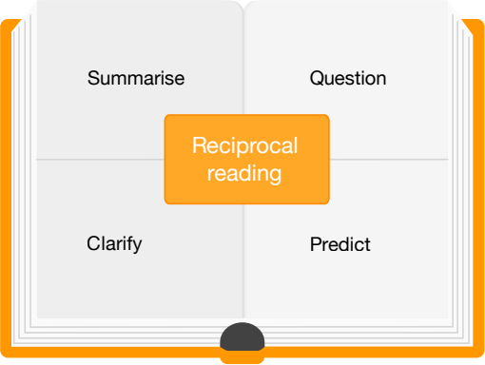

Figure 4- The reciprocal reading approach

Reciprocal reading through reading roles
Developing reading through specific reading roles has enabled students to understand different concepts, develop their vocabulary, improve their reading, articulate themselves appropriately and work together as a team. Whilst reading, each student takes on a specific role:
  - The Director develops questions to prompt thoughts, opinions, and feelings of the group.
  - The Helper locates passages that are harder to understand, which students then re-read and discuss
  - The Reporter reports on new vocabulary and definitions.
  - The Summariser summarises what was read and conveys main points succinctly.
Students then have an organised discussion based on question or statement posed by the Director, they communicate their ideas, developing and challenging points with a clear focus on academic language. Students can also include the new academic vocabulary, from the Reporter, where appropriate, adding to the quality of discussions . This format can be modified to suit different subject disciplines.

BREAK DOWN COMPLEX WRITING TASKS

“Writing is demanding because it requires students to combine three processes.”
The challenge of writing
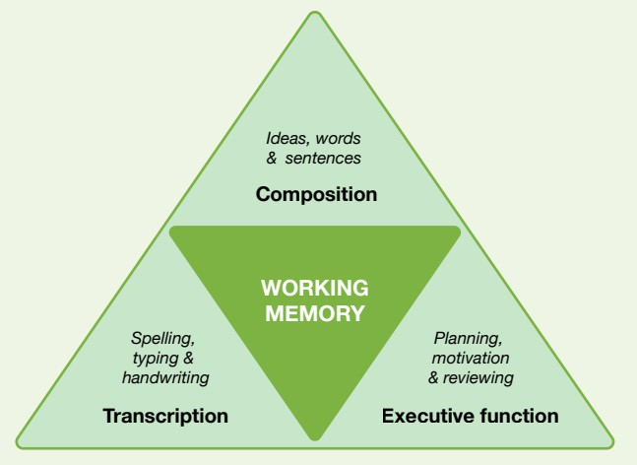
Writing is challenging, for teachers and students alike. Writing tasks, including high mark questions in exams, can require students to recall and marshal large quantities of information, communicate with accuracy and group ideas in structured ways. Understanding why writing is challenging and how complex writing tasks, including essays and extended answers, can be broken down can help students succeed across the curriculum. Writing is demanding because it requires students to combine three processes. Students must be able to transcribe, that is, physically write or type and compose, generating ideas and translating them into words, sentences, and structured texts. Finally, students must use executive functions, to enable them to make plans, motivate themselves and review and redraft texts. The complexity of writing means it can place a heavy burden on working memory, which can be thought of as the part of the brain where information is processed and combined. Students’ working memories can become overloaded if any of the processes involved in writing become too demanding.

Figure 5- Based on ‘The simple view of writing’
Teachers can help students break down writing tasks by:
  - Providing word-level, sentence-level and whole text level instruction. There is evidence to suggest that by focusing on the micro elements of writing for longer, students will ultimately be able to write longer, high quality responses. For example, in history, sentence starters can encourage students to analyse sources more deeply (for example, ‘While initially it might
appear that…, on closer inspection…’).
  - Ensuring that students understand the subject specific connotations of Tier 2 vocabulary used in writing questions. For example, in English Literature, “evaluate” questions often require students to justify their answers with reference to a personal response, whereas in Physical Education evaluation may require students to refer to the likely consequences, strengths and weaknesses of particular choices.
  - Explicitly teaching students planning strategies, such as how to use graphic organisers. Over time students should develop proficiency using a range of strategies and develop the ability to choose between them depending on task and audience.
  - Helping students monitor and review their writing, for example by providing a checklist of features included in high quality answers or using it as a self or peer-assessment tool.

When introducing any strategy, the teacher will model how the strategy should be used, for example, by speaking aloud to explain what she is doing and why, before students use the strategy themselves. After attempting to use the strategy, students should be given an opportunity to reflect on whether and why the approach was helpful in order to help them make links between the use of the strategy and success in the task. In common with wider evidence about modelling and scaffolding, it is recommended that over time assistance from the teacher is gradually removed, supporting students to become increasingly independent. Strategies can also be grouped together into sequences to create longer writing cycles.
A typical writing cycle will include planning, drafting, and editing stages. While not every writing task will require every step in the cycle, an important part of teaching writing is ensuring that students understand that expert writers in any subject follow multiple steps to create high quality work.
Teachers can also support students by:
  - Ensuring students’ transcription skills become automatic so that they can focus on other aspects of writing, and by quickly identifying students in need of extra support, which might include practising spelling, handwriting, or typing.
  - Recognising that students with difficulties with transcription – for example, related to dyslexia or dyspraxia – may not be able to demonstrate their true knowledge of a topic through written work unless extra support is available. Providing a computer can help improve the length and quality of writing from students identified as weaker writers, particularly when instruction in typing is also provided.
  - Using pre-writing activities that ensure students have secure background knowledge related to the topic they are writing about. For example, recapping key ideas before beginning a writing task will help students use them in writing more successfully.
Motivation
Motivation is also particularly important for success in writing. Students’ attitudes and self-perception matter in all aspects of literacy but appear to have a particularly strong effect on writing. Promising strategies to approach this challenge include the use of:
  - Collaboration- Students write together in pairs or writing teams and learn to provide structured feedback at each step of the writing process.
  - Competition- Such as challenging students to beat their previous score in self- or peer- assessed pieces of writing.
  - Self-talk- Encouraging students to celebrate successes in writing as a key component of
approaches to writing based on “self-regulated strategy development”. Studies involving this approach have shown promise in a range of subject areas, including secondary English in English schools.

COMBINE WRITING INSTRUCTION WITH READING IN EVERY SUBJECT
Reading and writing are complementary skills It can be tempting to see good writing as something that flows seamlessly from an understanding of the ideas and concepts that have been studied: if
students understand the material, then shouldn’t they be able to write about it effectively? However, while subject knowledge is undoubtedly necessary to write about a topic, this view is likely to be unhelpful for two reasons. First, content knowledge alone may not be enough to enable students to write well. Students are likely to benefit from instruction in the ‘rules of writing’, which will vary in each subject area. Second, it overlooks the potential of writing to deepen students’ understanding of key concepts and ideas. In reality, reading and writing are overlapping, complementary skills. As students read or write, they draw on a common body of knowledge, related to the topic being studied, and to their understanding of texts, syntax, and vocabulary. Reading and writing also enhance one another. Reading has been shown to improve the quality of students’ writing, while writing about texts improves students’ reading comprehension and fluency. While it is not a mistake to spend some time teaching reading and writing separately, it is beneficial to consider how to integrate reading and writing instruction, and likely to be a missed opportunity to think of writing as something that
happens after students have ‘learned the material’.
Reading high quality texts in every subject, for example those that effectively illustrate the conventions of particular types of writing, gives students an opportunity to observe the discipline- specific aspects of writing that relate to particular subjects. In English Literature, this might mean developing an understanding of how writers use form and language to create coherent themes within texts, while in art lessons this might mean understanding how critics identify layers of meaning within paintings. Effective ways of combining reading and writing include:
  - Writing before reading, for example by asking students to bullet what they currently know about a topic or generate questions they will later try to answer through reading.
  - Using annotations to identify information or explore key features of texts, e.g., underlining information about the types of evidence being cited in a science textbook.
  - Asking students to write short summaries of texts they read; although this is a skill which some students may struggle with initially, writing a one sentence summary of a paragraph, for example, can help students think more carefully about the meaning of what is written, and monitor their comprehension of the text.
  - Creating checklists based on examples of good writing in each subject. For example, while reading a geography textbook, the teacher might ask students to highlight words related to cause and effect, such as ‘Due to this…’; ‘A contributory factor was…’. Students can subsequently use checklists and examples in their own answers.
  - Anticipating common misconceptions or errors and highlighting how writers avoid them in high quality texts. For example, in science, students might mistakenly believe that theories
can be ‘proved’; it would therefore be beneficial to highlight phrases that experienced writers use instead. For example, instead of saying “This proves the theory that…” expert writers say: “This theory is supported by the fact that…” or “This evidence is consistent with the theory
that…”

Spelling, punctuation, and grammar
Fast and accurate spelling is a key component of writing fluency. Research suggests spelling should be actively taught, rather than simply tested. Hence IGHS aims to teach spelling through the following strategies-
  - Teaching groups of related spellings alongside a discussion of the morphology and etymology, prioritising words that are linked to content that is currently being studied rather than from decontextualized word lists.
  - Pre-teaching spellings of challenging words and anticipating common errors, for example, ‘government’ in politics or ‘Shakespeare’ in English Literature, homophones such as ‘there’ vs. ‘their’ or joining errors, for example, ‘alot’ instead of ‘a lot’.
  - Helping students recognise familiar patterns of letters within words and sound out words based on their knowledge of phonics.
  - Collaborative approaches, for example, grouping students and asking pairs to come up with memorable strategies for spelling challenging words.
  - Teaching students to self-quiz using retrieval practice, for example, using flash cards.
There is also a relationship between spelling and handwriting. While it is not the case that poor handwriting necessarily results in poor spelling, handwriting that is not fluent can have a negative
impact on spelling if it uses up a student’s cognitive resources. Evidence on teaching punctuation and grammar is mixed. Multiple reviews indicate that teaching grammar as a stand-alone topic in a decontextualised way does not have a positive impact on writing quality, with some syntheses even indicating a negative effect. Instead, it appears more promising to teach grammar in a way that highlights how grammatical changes can convey different types of meaning in the context of given types of writing, rather than on defining and describing grammatical terms in the abstract.
Hence, IGHS intends to combine contextualised grammar instruction across different subjects. For example, to support students to write with precision about competing arguments in History, teachers might find it helpful to explicitly explain to students the role of modal verbs like ‘could, would, should’ and ‘might’, or the way in which adverbs can be used to create more fine-grained distinctions
between judgements. For example, instead of saying “If Hitler had been killed at the Beer Hall Putsch, the war would have been prevented,” as historians we would say: “Arguably, if Hitler had been killed at the Beer Hall Putsch, the war might have been prevented.” In addition, there is consistent evidence supporting sentence-combining activities, which involves asking students to create more sophisticated sentences by combining two or more basic sentences. For example, students might be given the basic sentences, ‘Tudor clothing was uncomfortable’; ‘The Tudors dressed up for extravagant parties’ and asked to combine them, for example, ‘despite the fact that Tudor clothing was uncomfortable, the
Tudors dressed up for extravagant parties,’ as part of a lesson about the importance of image and
reputation in Tudor England.
Teachers in different subjects should not feel obliged to teach grammar that is not relevant to their discipline. But conversely, where understanding of a particular piece of grammar or punctuation will support students to succeed, the literacy coordinator may provide support to teach students how to use it for effect in their writing. Teachers should also consider the types of feedback they provide on errors related to spelling, grammar, and punctuation. For example, careless mistakes should be marked differently to errors resulting from misunderstanding. The latter may be best addressed by providing hints or questions which lead students to underlying principles; the former by simply marking the mistake as incorrect, without giving the right answer.

PROVIDE OPPORTUNITIES FOR STRUCTURED TALK
The importance of talk across the curriculum
Talk is a powerful tool for learning and literacy. It can improve reading and writing outcomes, enhance communication skills, and increase students’ understanding across the curriculum. In many subject areas, not only English, developing students’ skills of communication and argument is also a curricular end in itself.
Accountable talk
Quality of talk is likely to be more important than quantity. Improving quality means much more than getting students to talk more, or, as a teacher, trying to talk less. Instead, quality is more likely to be improved by considering structure and variety. One helpful structure for thinking about discussion in the classroom, developed by the academic Lauren Resnick et al, is known as “accountable talk”. The framework highlights the importance of accountability to:
  - Knowledge- for example, by seeking to be accurate and true.
  - Reasoning-for example, by providing justifications for claims.
  - Community-for example, listening and showing respect to others.
Importantly, the framework encourages teachers to think about the subject specific features of discussion. For example, in seeking to make students accountable to knowledge during a debate, a religious studies teacher could prompt speakers to refer back to quotes from key texts. Likewise, the teacher will be prepared to step in to correct misconceptions that arise as the debate develops.
Reasoning is also often subject specific. The word ‘evaluate’ has different meanings across different subjects. Some subjects will require students to assess the reliability of sources, while others will invite personal responses. While some students may pick up these subtleties implicitly, the majority are likely to benefit from explicit teaching of how to reason within each discipline. There is likely to be commonality in the ways students are accountable to community in different subjects and schools may find it useful to consider curriculum wide routines and expectations, for example, listening carefully and speaking calmly. However, in addition to expectations about conduct, accountability to community also emphasises the importance of making students feel that their contributions in class matter, for example, by emphasising the value of errors.
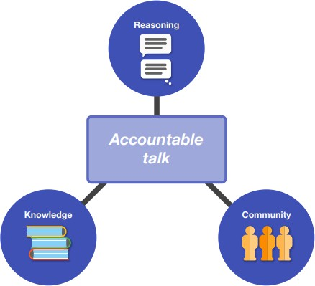

Figure 6-- Based on the model of accountable talk by Resnick et al

Metacognitive and self-talk
Students also benefit from metacognitive talk, which focuses on the processes of learning, and on dealing with barriers to learning. For example, in food technology, metacognitive talk seeks to answer questions like: ‘What equipment do I need before I begin cooking?’ or ‘What will I do if I fall behind my time plan?’ Metacognitive talk will often be task and subject specific. For example, after introducing a range of strategies that can be used to break down an as-yet unseen poem, English teachers might ask students to discuss, in pairs, the strategies they have previously used, plan which strategy they will use to tackle a new example, and review whether this strategy helped them tackle the poem.
Evidence is also emerging related to ‘self-talk’. Two forms of self-talk are-
- Elaborative interrogation, which requires students to generate explanations for why
something is true (for example, ‘Why does performing the same operation on both sides of an equation not change the answer?’)
- Self-explanation, whereby students are prompted to ask themselves questions about what they are studying (for example ‘How does this pair of equations compare to others I have solved?’).
Putting it into practice
Effective ways of promoting high quality talk in Islamiyah High School include:
  - Teachers modelling what effective talk sounds like in their subjects. This includes using subject specific language and vocabulary, explicitly introducing the ways of reasoning that matter within their discipline, and the ways in which experts use metacognitive talk.
  - Deliberately sequencing talk activities alongside reading and writing tasks to give students opportunities to practise using new vocabulary, develop ideas before writing, or discuss ways to overcome common challenges (‘tell your partner what to do if they get stuck’).
  - Using sentence starters and prompts to help students to structure and extend their responses. For example, starters such as ‘my claim is based on the fact that…’ can help students link to evidence, while a shorthand like ABCQ (Agree, Build, Challenge, Question) sets out different ways to contribute to a discussion. Teachers can prompt students to extend their answers with questions, e.g. ‘Can you use ‘moreover’ to link to a second piece of evidence?’
  - Selecting questions that are open-ended, well-suited to discussion and allow opportunity for authentic student response rather than direct replication of teaching: for example, where there are several plausible answers and where students’ own views might develop.
  - Setting goals and roles, particularly for small group discussions. By ensuring students have a clear goal—for example, a question to answer— it is more likely that talk will be focused and that students fully participate. This type of approach can overlap with some reciprocal reading activities.
  - Using wait time to develop students’ responses, by leaving a pause after they have first given
an answer, which gives them a chance to reframe, extend, or justify their reasoning.
  - Giving precise feedback relating to different elements of accountability. For example, in addition to praising a student’s use of evidence, teachers might praise the way in which students follow the norms of discussion, for example, by naming classmates or linking new contributions explicitly to previous points.
  - Students can also be trained to provide peer feedback during talk activities, for example, related to the use of new vocabulary.

PROVIDE HIGH QUALITY LITERACY INTERVENTIONS FOR STRUGGLING STUDENTS
Tiers of support
High quality teaching across the curriculum intends to reduce the need for extra literacy support. Nevertheless, it is likely that a small number of students will require additional support, in the form of high quality, structured, targeted interventions, to make progress. Tiers of support move from whole class teaching through small group tuition to one-to-one support, increasing intensity with need. IGHS will be collaborating with Fortis Academia to provide small group tuition as the initial intervention option, taking care to bring together students who are struggling in the same area of literacy, before moving to one-to-one tuition if small group tuition is ineffective.
The role of assessment
Effective intervention is impossible without assessment, which can be used to:
  - Identify students requiring additional support
  - Identify their needs so that support is well-targeted
  - Assess progress and the impact of interventions.
There are a wide range of literacy problems that secondary-age students might have, related to speech, language and communication, phonics, reading fluency, vocabulary and reading comprehension. In addition, students may have wider difficulties, for example, related to eyesight. Unless interventions are well-matched to underlying difficulties, they are unlikely to be effective. Some assessment can be undertaken by teachers as part of regular monitoring and assessment in class. However, while classroom teachers are likely to be able to identify broad categories of challenge, in many cases, this should be followed up with more detailed diagnostic assessments, including standardised tests.
IGHS will use the School Plus student reports and assessment data, to identify students, targeting interventions and monitoring progress. Five useful questions for teaching and intervention teachers to ask when interpreting this data are:
  - What did the standardised test measure and not measure? For example, if scores relate to a word reading task and a student receives a low score, this will indicate word reading support is needed. However, it does not tell us whether this child also needs support for reading comprehension.
  - What kind of scores do we have and how can they be interpreted? Often reading ages are provided by standardised tests. While these appear intuitive, they can be misleading. Other scores, such as percentile ranks, are likely to be more helpful, and communicate how many students in this age range are likely to perform lower than this student. The average range for students is from the 16th to the 84th percentile, which equates to a ‘standard score’ (like an IQ score) of 85–115.
  - What do the scores tell us about progress? Percentile ranks and standard scores that stay the same show that students have made expected progress. If they go down then progress is less than expected, if they go up, more progress than expected.
  - How do the results we have compare to other tests and data? It is important to contextualise the results of standardised assessments by comparing them with teacher assessments and other sources of data; a judgement of need is likely to be more reliable when it is supported by information from across these sources, and it is not advised to rely too heavily on the results from a single assessment.

  - What is the data being used to assess? When students are identified as struggling, it can be tempting to introduce a range of interventions at the same time. However, a drawback of this approach is that it is difficult to identify the impact of any individual approach.
Literacy programmes
Effective targeted interventions implemented by IGHS-
  - Regular sessions that are maintained over a sustained period and carefully timetabled to enable consistent delivery.
  - Structured supporting resources and/or lesson plans with clear objectives for literacy intervention sessions.
  - Assessments to identify appropriate students, guide areas for focus, and track student progress.
  - Connections between the out of class learning and day-to-day whole class learning. Motivating students
Motivating students to engage with literacy interventions is also a common challenge. However, some principles drawn from wider research include:
  - Seeking to develop students’ feelings of self-efficacy- for example, by carefully scaffolding tasks and by explicitly linking the use of particular strategies to improvement.
  - Selecting tasks that are engaging-for example, some collaborative learning approaches have been found to be effective at improving adolescent literacy, particularly when students are required to work as a team towards a common goal.
  - Sharing strategies between teachers in different subjects.
  - Ensuring students have an opportunity to use skills from the intervention setting in the classroom and across different subjects.

REFERENCES-
- ‘What is Disciplinary Literacy and Why Does it Matter?’ by Timothy and Cynthia Shanahan (2012).
- ‘Reading comprehension and vocabulary: what’s the connection?’ by Professor Kate Nation,
University of Oxford.
- Ending the Reading Wars: Reading Acquisition from Novice to Expert, by Anne Castles, Kathleen Rastle, and Kate Nation.
- Teaching Secondary Students to Write Effectively, published by the What Works Clearinghouse (2017)
- Disciplinary Writing Guides (Various Subjects), published by Harvard University.
- Accountable Talk: Instructional dialogue that builds the mind by Lauren Resnick, Christa Asterhan and Sherice Clarke.
- The Education Endowment Foundation’s Promising Projects list, available on the EEF
website.

