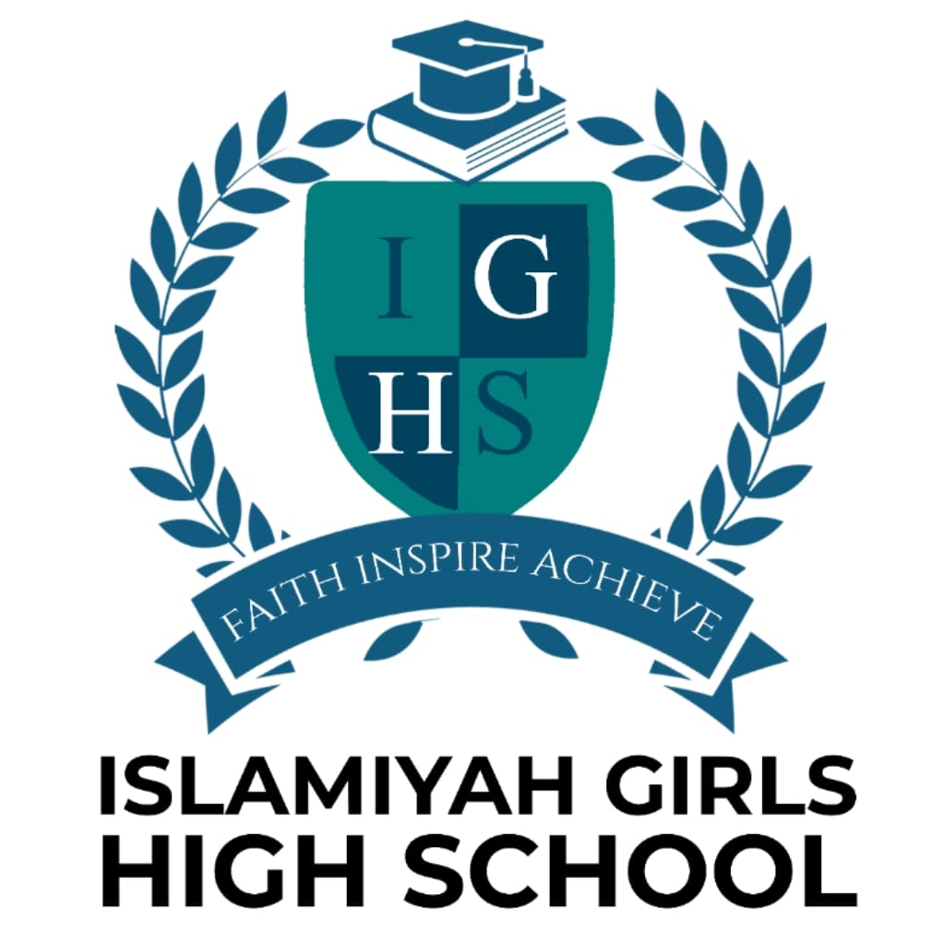

ISLAMIC ETHOS

POLICY

2026-2027

This document has been approved for operation for - Islamiyah Girls High School

Last Reviewed – June 2026

Next review – June 2027

Review Period – 1 Year

Owner – Islamiyah Girls High School

Approved By – Governing Body

Islamic Ethos Policy

Islamiyah Girls High School is a school with an Islamic Ethos.
Through our ethos we aim to nurture our students to become young confident individuals, to develop their identity as responsible British Muslims and to always aspire towards achieving the highest goals. Our Academy aims to develop young practising British Muslimahs who are confident role models, and women who are prepared to take their place in benefitting modern society.
Alongside the National Curriculum we provide Arabic and Islamic studies, and all aspects of the curriculum are permeated with the Islamic ethos. Each lesson begins and ends with a dua (supplication), and teachers are encouraged to display the Islamic date alongside the Gregorian dates- this is usually reflected in students’ books.
Moreover, we aim to nurture our students within an Islamic environment, therefore, each day begins with taleem, an Islamic themed assembly or reading from the Holy Qur’an. We place emphasis on marking notable Islamic events and observances through lessons, assemblies or extra-curricular days.
Our school is a close-knit community and has often been likened to ‘one big family’, and just as any responsible family we seek to inculcate in our students the core universal principles of equality, fairness, justice, tolerance and respect for people of all faiths and backgrounds.
Just as we encourage our students in their endeavours towards academic success, we also recognise the equal importance of supporting their journey towards spiritual awareness. Students have the benefit of an environment in which to explore and develop their values, and all students are expected to hold themselves to the highest standards of personal conduct and behaviour.
At IGHS we take a holistic approach to developing well-rounded individuals: students who value and respect themselves, others around them, as well as the wider community they reside in.
The foundation of the Academy is based on the Qur’an and Sunnah (tradition) of the Prophet Muhammad (peace be upon him), therefore, the Islamic Ethos is at the heart of everything we do.

