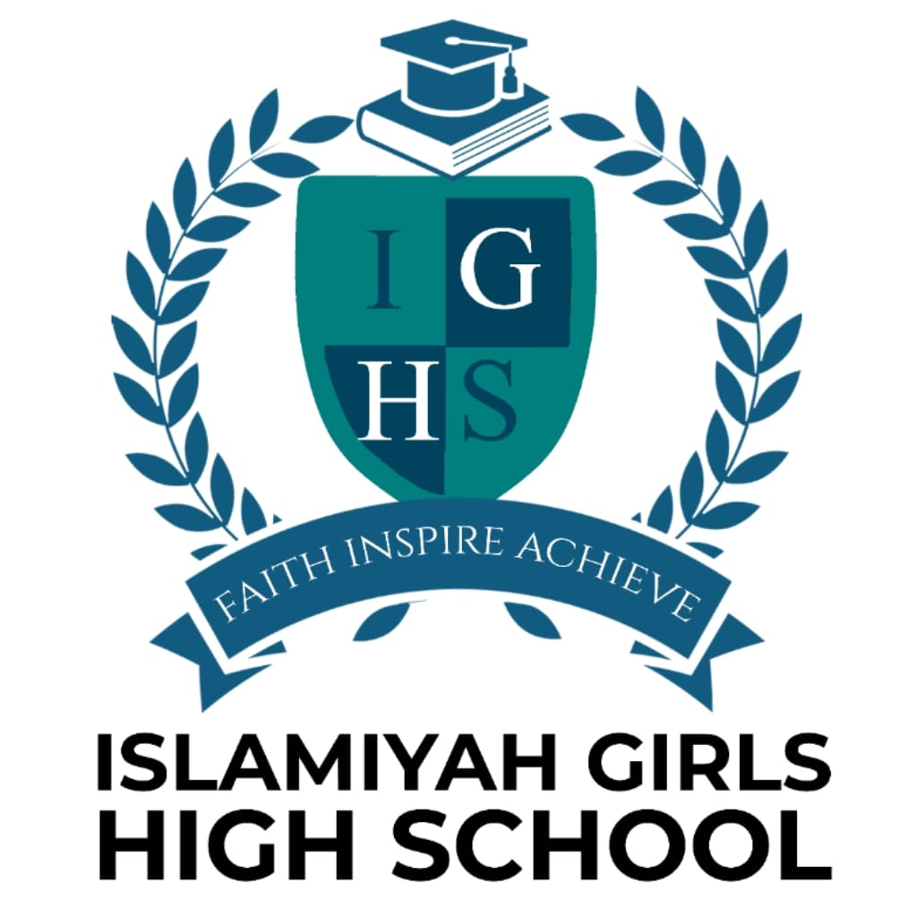

CURRICULUM

POLICY

2026-2027

This document has been approved for operation for - Islamiyah Girls High School

Last Reviewed – June 2026

Next review – June 2027

Review Period – 1 Year

Owner – Islamiyah Girls High School

Approved By – Governing Body

- INTRODUCTION

This policy reflects our school’s ethos and its intention to offer the highest quality of teaching and learning, within an Islamic framework, which will equip our students for life in their community, modern Britain and the wider global society.

The curriculum at IGHS is designed to nurture resourceful, enquiring minds capable of reaching the highest levels of achievement, creativity and personal development, fostering young people who are curious and enthusiastic with a genuine love of learning, and the resilience to play their part in society as confident, independent young Muslim women.

The value of our curriculum goes beyond what is taught and examined, encouraging the personal development of students both inside and outside of the classroom, enabling all students to take their place in an ever changing world as active, valued and respected members of society. At IGHS there is a strong focus on providing students with a rich set of experiences, within both the academic and extra−curricular fields.

- OUR SCHOOL CONTEXT

IGHS is an independent Muslim Girls’ School, with a catchment area that covers a wide radius around Blackburn and surrounding local authorities. We have few students who are truly local to the school, with most travelling some distance to come here. Although currently and historically all students have been of the Islamic faith, they come from a very wide range of cultural and national backgrounds, and consequently we have many EAL students.
However, although many speak a different language at home, all can communicate fluently in English.

The school context has an impact on the curriculum in terms of access to extra−curricular activities as many students cannot stay after school because of where they live, especially those in the lower year groups. We compensate for this by offering a wide range of lunchtime activities and delivering a variety of clubs on the last day of each term, which all students can access.

The current school building also has an impact on the range of subjects we are able to offer. We occupy a small site in a residential area, with no scope for expansion. This means that we are unable to offer technical subjects such as food technology or design technology, and there is limited space (both indoor and outdoor) for sport. However, we cover areas such as drama via our extra−curricular provision.

- CURRICULUM INTENT

A broad and balanced curriculum is a vital component of our commitment to enable all our students (including those with SEND) to become successful learners with a clear understanding of their place in society and the highest aspirations for their future. Everything children learn in school − the taught subject timetable, the approach to spiritual, moral, social and cultural development, the extra−curricular provision and the ethos of the school − are seen as part of the whole school curriculum.
The IGHS curriculum is designed to provide all students with the core knowledge they need for success in education and later life, to maximise their cognitive development, to develop the whole person and the talents of the individual. It combines academic rigour, curiosity and creative flair with the fostering of the key skills and personal qualities required to support future success.

Academically, it is designed to ensure success at GCSE and to generate maximum opportunities for study post 16. The school aims to provide an inclusive, broad and balanced curriculum that enables all students to acquire knowledge, understanding and skills in all aspects of their education, including the humanities and linguistic, mathematical, scientific, social, physical and artistic spheres.

The academic curriculum is supplemented by a strong careers program which informs students of the possibilities available to them and how these can be achieved, and guides them in making the right choices for themselves as individuals.

The RSHE curriculum is founded on moral principles and a recognition of the value of family life. The SMSC/PSHE curriculum is devised to develop the whole person, and to give rich and sustained opportunities to maximise cultural capital.
Wherever possible, the curriculum at IGHS teaches the British values of tolerance, mutual respect, democracy, the rule of law and individual liberty. Beyond timetabled lessons, students are given many opportunities to develop the appropriate skills and attitudes needed to make a valuable contribution to society, both now and in the future.
Students gain an understanding that such values align with the Islamic ethos of the school, and support wider communal engagement in their future lives.

Our students will:

- Achieve well from their starting points
- Experience a broad and balanced curriculum that leaves them able to make powerful choices about their future ambitions.
- Be imaginative, optimistic and inventive
- Become effective communicators
- Experience creative teaching that makes learning engaging and allows them to think independently
- Be expected to embrace a diverse range of creative opportunities both inside and outside the classroom.
- Become confident, resilient, well−rounded citizens who understand national and global communities as well as their local society, and are ready to discover their place in it.
- Be work ready and well prepared for the opportunities, responsibilities and experiences of adult life
- Be proud of their achievements and the progress they make, and have these achievements celebrated and recorded.
- Develop positive, secure relationships so that they flourish and have a powerful sense of their own identity and potential

Our curriculum will:

- provide academically rich and coherent learning which leads to deep subject knowledge
- have breadth and balance across a range of subjects, with an appropriate emphasis on the intrinsic faith of the school
- ensure all students (including those with SEND) learn exceptionally well
- promote character and personal, social, physical, spiritual, moral, and cultural development
- ensure that students develop the essential skills in reading, writing, communication, numeracy and independent learning
- inspire students to a commitment to learning which will last a lifetime
- promote a healthy lifestyle
- promote community cohesion and the fundamental British values of democracy, the rule of law, individual liberty, and mutual respect and tolerance of those with different faiths and beliefs

CURRICULUM IMPLEMENTATION

- The curriculum is driven by the leaders of the school through the embedding of long−term curriculum overviews and medium−term plans for every unit/module of work within a subject. Subject leaders, in consultation with their team members, decide the core knowledge and skills to be taught and in what order. All lessons are delivered by subject specialist teachers, who are responsible for their own day to day lesson planning under the guidance/direction of the Head of Department (where applicable).
- We are ambitious for all our students, and have high expectations of them in terms of attitude to learning. Teachers plan with the knowledge that some learners will need more scaffolding, whilst others will require a greater challenge. We aim to meet the academic needs of all learners every lesson through the use of differentiated questioning and resources. Students are expected to work hard and display excellent attitudes to learning in all lessons. Learning is maximised by clear behaviour expectations and classroom routines that support students to focus on learning and ensure there is no wasted time from low level disruptions. Students are expected to develop strong independent learning skills but also to be able to function effectively in groups and pairs.
Independent learning is fostered in the classroom but also via a systematic approach to homework which ensures students develop effective personal organisation and independent learning skills, gradually raising the expectations of students to complete a greater quantity and higher quality of learning outside the normal school hours.
- We pride ourselves on our extensive programme of trips, workshops and events which our students participate in, ensuring they are exposed to a diverse and inclusive range of voices and experiences. Through our curriculum choices, our students are taught to respect and value other peoples’ values, culture and perspectives.

- KEY STAGE 3

We provide an ambitious, broad, balanced and comprehensive curriculum that provides a clear transition between primary and secondary school and builds a firm foundation for progression to Key Stage 4 and sixth form college. Students experience a range of subject areas to inform and inspire their learning. The core programme consists of
- English
- Maths
- Science
- RS and Islamic Studies
- History
- Geography
- Arabic
- Art
- Art
- ICT
- PE

PSHE is delivered once a week
A program of careers education that is part of the curriculum in all year groups. All students study age−appropriate RSHE

KEY STAGE 3 LESSON PROVISION – NUMBER OF LESSONS PER WEEK
SUBJECT | YEAR 7 | YEAR 8 | YEAR 9
MATHS | 4 | 4 | 5
ENGLISH | 3 | 4 | 5
SCIENCE | 4 | 4 | 5
ART | 1 | 1 | 1
ARABIC | 1 | 3 | 3
ICT | 1 | 1 | 2
GEOGRAPHY | 2 | 2 | NA
HISTORY | 2 | 2 | 2
PE | 2 | 2 | 2
RS | 2 | 2 | 2
ENRICHMENT | 1 | 1 | 0
URDU | 2 | 2 | 2
 | 25 | 25 | 25

- KEY STAGE 4

It is vital that all our students continue with an ambitious, broad and balanced curriculum at Key Stage 4. Students are expected to complete nine or ten GCSEs:

- English Language and English Literature
- Maths
- Science (Trilogy or Triple)
- Religious Studies
- History
- Business
- Urdu

Non GCSE Subject
PHSE and Pe Will continue as non GCSE subjects in ks4

KEY STAGE 4 LESSON PROVISION – NUMBER OF 1 hours lesson
COMPULSORY SUBJECTS
MATHS | 6
ENGLISH | 6
SCIENCE | 6
PE | 2
RS | 2
BUSINESS | 3
HISTORY | 3
SEPARATE SCIENCE | 6
URDU | 2
Arabic | Optional -alongside urdu lessons

- SPECIAL EDUCATIONAL NEEDS AND DISABILITY

IGHS values the abilities and achievements of all students. The Learning Support Team supports the early identification of students with special needs and staff will differentiate appropriately for the needs of all students in lessons, ensuring equality of access.
See SEND policy

- ENRICHMENT

Learning at IGHS extends beyond the taught curriculum and all students have access to a range of activities and experiences to extend their learning and development. All students are actively encouraged to participate in enrichment activities and take on roles of responsibility to enhance their personal development. Initiatives include

the Duke of Edinburgh Award Scheme, Peer Mentoring, STEM challenges and Work Experience. We offer wide ranging positions of responsibility in all year groups, including form monitors for various aspects of school life, Prefects and school council.

- PSHE

Personal Social Health and Education is about the development of key skills of the individual leading to an Islamic self−empowerment and self−esteem, so that our pupils will be those who grow into adults aware of their personal potential, are prepared for adulthood, who have formulated a moral code of conduct and have the conviction to live by it, who care about others and aim to do something in their service, who think about society and try to improve it; who can manage their own life and can cope with the ever increasing pace of change in today’s society.

The PSHE curriculum is delivered via eight discrete days over an academic year, including a cross−curricular day and a diversity day where the normal timetable is collapsed. This format allows for a wider range of activities and events to take place than would be possible via a single weekly lesson, include trips outside school and presentations/workshops delivered by guest speakers/experts in different fields.

The aims of the PSHE curriculum are that students:

  - Know and understand what constitutes a healthy lifestyle.
  - Be aware of safety and risk issues. v Understand what makes for good relationships with others. v
  - Develop social skills to enable successful relationships with all members of their community.
  - Learn to respect and understand common humanity, diversity and differences so that they can go on to form the effective, fulfilling relationships that are an essential part of life and learning.
  - Develop as independent and responsible members of the school, local and global community.
  - Gain an understanding of their role as British citizens, able to identify and understand what British Values are and how they can implement them in their daily lives and respect the protected characteristics as defined in the 2010 Equality Act (disability , gender reassignment, marriage and civil partnership, pregnancy and maternity, race, religion or belief, sex and sexual orientation)
  - Find out about the main political and social institutions which affect their lives and know and understand what it means to be a positive and active member of a democratic society.
  - Develop self−confidence and self−esteem.
  - Are able to make informed decisions about personal, social, physical, spiritual, moral and cultural issues.
  - Develop financial capability skills for future economic well−being.
  - Are able to identify and report any safeguarding signs or issues
See separate PSHE policy for full details.

